# Labjournal

## Week 1

### 2018-03-21

What did we do

* Built a set-up (figure 1): using a pre-3D printed scaffold for droplet positioning, home-made LED set-up contained in an eppendorf box for diffusion. To this we added a breadboard and shock absorbers to minimize oscillations of the droplet while measuring as this will affect the result.
* We tried to control a syringe pump by computer. This failed, as the communication via the I/O port was not in line with the provided software communication protocol. We decided to put the problem on hold.
* We tried to use opendrop, the software in Python from the paper by Tabor. We were unable to run this, due to errors probably caused by a lack of installed modules. We decided to move on to use Matlab as it has a built-in image processing toolbox. We found the function Hough transform in Matlab that looked promising for identifying the edges of the droplet in the image.



Figure 1 Set up of the drop tensiometer

What are we going to do

* Improve the setup by building a holder for the smartphone so the camera is stable while filming, and by increasing the stability of the light source.
* Flow behaviour and elasticity

### 2018-03-22

What did we do

* Write Matlab code to locate the droplet on the picture. This was done by converting the edges of the droplet to lines, and the converting these lines to points. Thereafter we divided the image into boxes of different size. The points in each box were fitted to a circle with a diameter of half the box size. For this we used the equation x2+y2=R2. The box were this fit led to the least error was picked as the location of the droplet. This did not give us the droplet location as the droplet was not a perfect circle. Some boxes turned up with only 1 centred point in it because we did not divide the error by the number of points in the box.
* Design instrument including smartphone holder and lightsource stabilization to be 3D printed. Design can be found in Pendant_drop_meter.123dx. During the designing the light source broke.

What are we going to do

* Print the design of the instrument with a laser 3D printer
* Find a way to implement a syringe pump in the set up to accurately control volume growth of the droplet
* Solve the problems in the code to accurately find the droplet on the image
* Flow behaviour and elasticity

### 2018-03-23

What did we do

* Light source has been fixed.
* We wanted to print the design with the 3D printer. Unfortunately the printer was already printing something else. Therefore the design will be printed at the end of this day and we can continue our work after the weekend.
* We tried to initiate communication between the computer and the syringe pump. It seems that the computer software available for the syringe pump is too old to be supported on the computer. The syringe pump started pumping when the software was started, but could not be controlled further by the software, not even to be switched off. We decided to control the syringe pump manually.
* We solved the MatLab problems with locating droplets. For this we changed the requirements thus that all points should have an equal distance to the centre of the box and that the mean of all points added together was equal to the centre of the box. The error was divided by the number of points in the box. The box with the lowest error indeed contained the droplet. Furthermore, we cropped the image based on the box size in which the droplet was found.

What are we going to do

* Writing code to rotate the image so that the needle is parallel to the force of gravity, to fit the young-laplace equation.
* Flow behaviour and elasticity

## Week 2

### 2018-03-28

What did we do

* + The design was 3D printed. Unfortunately the first two attempts at printing went wrong. At the first attempt the 3D printer seemed to have dropped the object before it was dried and therefore it was completely malformed. At the second attempt we ran out of printing material before the object was finished. The third attempt was done with another 3D printer and yielded the correct design. We polished the slid for the light diffuser to remove excess material and improved the fit of the light diffuser. We added Styrofoam to the phone holder to protect the smartphone from scratches and improve the fit. There was no polishing needed for the needle holder as it had a diameter that was a little to large for the needle. Therefore, we increased the diameter of the needle with tape to improve the fit. We then build the set up on a breadboard with shock absorbers and added the syringe pump to control droplet volume. The complete set up is shown in figure 2. With this set up we made test pictures (see figure 3) and a movie of a growing droplet.
  + We made a function called ‘MakeDroplet’ that simulates the shape of a droplet based on the bond number. For this we used the coupled set of differential equations obtained when the Young-Laplace equation is expressed in terms of the cylindrical coordinates *r* and *z* used in Berry et al. We also devised a plan to rotate the image to make the needle parallel to the y axis of the image. This should make fitting of the Young-Laplace theory easier. To determine the sin of the angle by which the image should be rotated we want to divide the width of the needle by the distance between the intercepts of the edges of the needle with the top of the picture.



Figure 2 New set up.

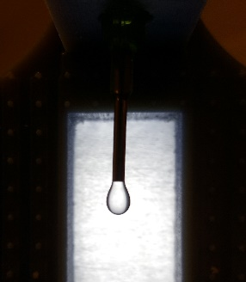

Figure 3 Test picture of a water droplet made with the new set up

What are we going to do

* + Rotate image based on needle intercept and fit picture with the simulated droplet based on Young-Laplace equation.
  + Flow behaviour and elasticity

### 2018-03-29

What did we do

* + Made video of oscillating droplet using a syringe pump
  + We finished the MatLab code to find the angle (θ) by which the image should be rotated and called it NeedleAnalysis. To do this we first located the intercepts of the needle edges and called these b1 and b2. Then we divided the y-axis of the image into segments and located the edges of the image in these segments. For the edge in each segment we calculated the angle with b1 and b2 by taking the arctangens of the gradient. These angles were expected to be bigger when the droplet was reached. Therefore, if both the angle with b1 and the angle with b2 exceeded a certain critical angle the values were omitted to make sure we only measured the angle between the needle and the top of the picture. Then we used the angles of the needle points with b1 and b2 to determine θ. We calculated the needle width by multiplying the distance between b1 and b2 with the cosine of θ.
  + We made a MatLab code to find the lowest point of the droplet and centre the picture around x0 and y0 called Find_lowest_point. We set x0 at (b1+b2)/2 , which corresponds to the middle most x value of the needle. Then we set y0 at the minimal y value found for x0. We then plotted the picture with the new x and y values.

What are we going to do

* + Fit the simulated droplet based on bond number to the rotated and centred picture of the measured droplet.

## Week 3

### 20180404

What did we do?

* We have decided to no longer use the code that localizes the droplet in a complex image (LocateDroplet), as this requires a lot of effort to do properly and, as the set-up remains the same among different experiments, manual cropping is more effective and more precise.
* We wrote a function (FindDropletEdges) that finds the edges of a cropped droplet. This is important to scale the droplet to a width of 2 and translate the vertex of the droplet to (0,0). This function relies on screening the droplet image space in segments and then selecting the segments that contain the outermost points of the droplet, thus finding the edges.
* The function that simulates a droplet for a Bond number (MakeDroplet) is now resized as to correspond with the resizing of the droplet points. This is required for proper fitting.
* We wrote a fitter (YLFitter) that fits a set of experimental points to the Young-Laplace equation for a range (Bmin to Bmax with steps of a certain accuracy) of Bond numbers. This fitting is done by minimalizing the least distances of the experimental points to the Y-L equation simulation. The error is normalized for the number of experimental points to allow for comparison amongst different droplets.
* Iterative fitting was added to the main code, as to allow zooming on the region of best Bond numbers a few times to find a more accurate result for the Bond number.
* We added minor other improvements to and fixed minor mistakes in the code.

What are we going to do?

* Improve the FindDropletEdges function to make it more precise. It appears as if the edges are really fitted on the outskirts of the data points, instead of in the middle. This might give a bias in fitting.
* Calculate the droplet volume (V) from the Y-L equation, calculate surface tension and Worthington number from the obtained Bond number and radius.
* Make a list of suitable liquids that we want to test our set-up with.

Other ideas

* Flow behaviour and elasticity
* Measure surface tension of gelatin droplet while solidifying and try to relate surface tension to temperature
* Find the effect of a surfactant on surface tension of an oscillating droplet

### 20180405

What did we do

* We made movies of the dispensing of multiple solvents (water, ethylene glycol and ethanol). The movies were analysed with the software. From the obtained data we could conclude that, as suggested by Berry et al., the surface tension approaches the values reported in literature when Wo (Vdrop/Vmax) approaches 1 (see Figure 4).
* We had difficulties measuring the surface tension of ethanol (especially as function of time), as ethanol had a strong tendency to stick to the needle and form a droplet around the needle, instead of hanging from the needle (see Figure 5).

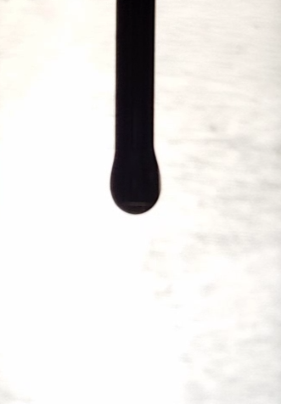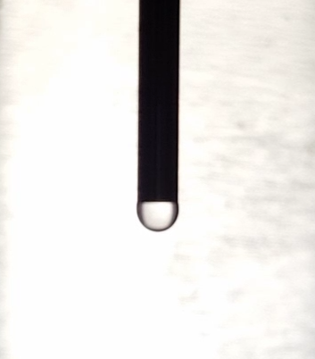

Figure 4 Droplet of ethanol during the dispension. A) Small droplet hanging from the needle. B) Bigger droplet, adhered to the needle (needle indicated with red lines).

* We made a list of interesting fluids to measure, and measured a number of those (water, ethylene glycol and ethanol).

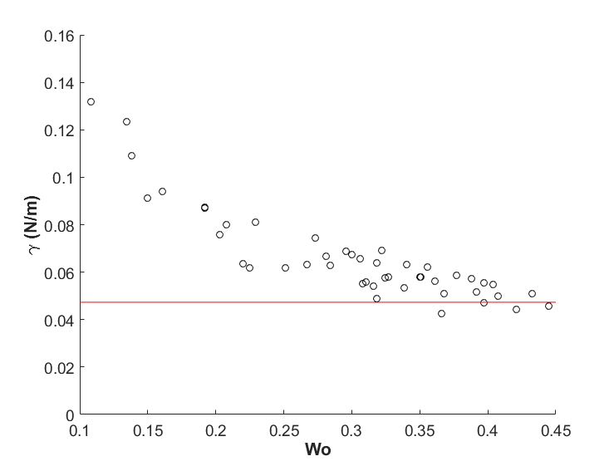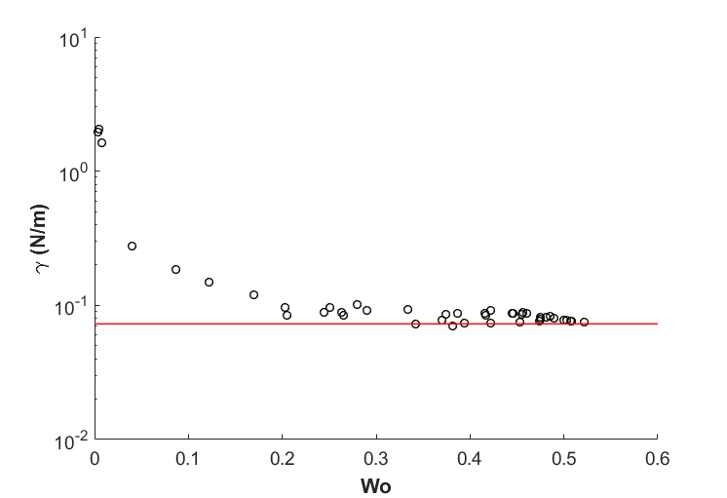

Figure 5 Surface tension plotted as function of the Worthington number (Vdrop/Vmax) for an ethylene glycol droplet (a) and a water droplet (b). The reported literature surface tensions are indicated by the red line.

**A**

**B**

* We edited the code of the programme as to enable the analysis of videos. The analysis code was called for each frame in a certain time range.
* We were able to convert from pixels to meters using the thickness of the needle as a conversion factor.
* Code was added to calculate the volume of a droplet in the MakeDroplet function, using the integral for revolution of a 2D space around the Z-axis.
* Wo and Gamma were calculated from the obtained Bond number in the code.

What are we going to do

* + Measure droplet containing pectin and lysozyme at different lysozyme concentrations to find optimal lag time for change in surface tension
  + Make droplet video of diethylene glycol and propylene carbonate
  + Measure surface tension using a wilhelmy plate
  + Find correct parameters by making droplet videos with higher resolution and use less slices in the fitting process
  + Flow behaviour and elasticity
  + Arduino/RaPI system
  + Measure surface tension of gelatin droplet while solidifying and try to relate surface tension to temperature
  + Find the effect of a surfactant on surface tension of an oscillating droplet
  + Use magnetic nanoparticles and a magnet to alter surface tension
  + Coat the needle with CF2 end groups exploiting aluminium oxide surface chemistry as to enable the measuring of low surface tension liquids such as ethanol.

### 20180406

What did we do

* The surface tension of water, ethylene glycol and ethanol was determined using the Wilhelmy plate method.
* A short protocol for the Wilhelmy plate method:
  1. Clean all glassware and rinse it with the solvent to be used.
  2. Measure the width of the plate and straighten the Wilhelmy plate.
  3. Rinse the Wilhelmy plate with ultra-pure water. After rinsing, dry and clean the plate by heating it, untill it is red-hot, with a butane-torch (only use torches that produce a blue flame, as other torches will leave carbon contamination on the plate).
  4. Hang the plate underneath the balance using tweezers (to avoid contamination), make sure the plate does not swing and tare the balance.
  5. Put the beaker on the platform under the plate and move the platform so the plate just touches the liquid.
  6. Wet the complete plate by slightly lifting the beaker with liquid.
  7. Wait untill the wait is stable.
  8. Calculate the surface tension by γ = 9.81 * M/2L, with γ the surface tension in mN/m, M the mass in g, and L the width in M.
  9. Repeat step 3 to 9 for the duplo/triplo measurement.
* Finished full analysis of videos of water, ethylene glycol and ethanol. These resulted in graphs that gave insight in the fluctuations of our parameters. This seemed to correspond well with the Wo number as predicted in literature.
* The final fitting process was visualized in a cartoon. This cartoon is shown below (figure 5).

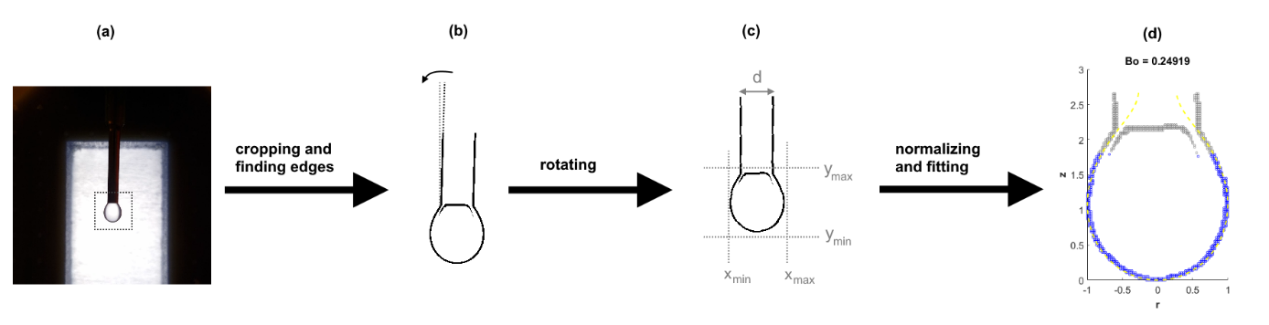

Figure 6 Cartoon of the fitting process. (a) An image of a droplet is cropped to a pre-defined space and (b) rotated based on the needle. (c) The image is analysed to find the edges of the droplet, which are used to (d) transform and fit the droplet to the Young-Laplace equation.

## Week 4

### 20180411

What did we do

* We measured surface tension of a 0.1 gram/litre ovalbumin solution with the wilhemy plate method for 30 minutes to see when surface tension (γ ) stabilizes (see table 1). We fit these data in excel with γ = a/(a+b)+c (see figure7).
* Searched for literature about protein adsorption kinetics in relation to surface tension to explain the fit we found with the Wilhelmy plate analysis.
* Measure surface tension of water over longer time periods with the set up in a box with a cup of water to minimize droplet evaporation. Droplet evaporation still occurred, therefore we assumed that the air was not yet saturated enough and decided to use cups with hot water. We also used a time-lapse app instead of the normal video function to get a smaller file that is easier to store.

Table 1 Surface tension of a 0.1 gram/litre ovalbumin solution per minute calculated from the mass measured with the Wilhelmy plate method.

|  |  |  |
| --- | --- | --- |
| t (s) | m (g) | γ (mN/m) |
| 0 | 0,3062 | 72,872 |
| 60 | 0,2982 | 70,968 |
| 120 | 0,2944 | 70,064 |
| 180 | 0,2911 | 69,279 |
| 240 | 0,2883 | 68,612 |
| 300 | 0,2864 | 68,160 |
| 360 | 0,2848 | 67,779 |
| 420 | 0,2836 | 67,494 |
| 480 | 0,282 | 67,113 |
| 540 | 0,2807 | 66,804 |
| 600 | 0,2797 | 66,566 |
| 660 | 0,2787 | 66,328 |
| 720 | 0,2773 | 65,994 |
| 780 | 0,2767 | 65,852 |
| 840 | 0,2756 | 65,590 |
| 900 | 0,2749 | 65,423 |
| 960 | 0,2741 | 65,233 |
| 1020 | 0,2732 | 65,019 |
| 1080 | 0,2722 | 64,781 |
| 1140 | 0,2714 | 64,590 |
| 1200 | 0,2707 | 64,424 |
| 1260 | 0,2699 | 64,233 |
| 1320 | 0,2688 | 63,972 |
| 1380 | 0,2682 | 63,829 |
| 1440 | 0,2677 | 63,710 |
| 1500 | 0,2668 | 63,496 |
| 1560 | 0,2663 | 63,377 |
| 1620 | 0,266 | 63,305 |
| 1680 | 0,2654 | 63,162 |
| 1740 | 0,2648 | 63,020 |

Figure 7 Surface tension of a 0.1 gram/litre ovalbumin solution over time. The result was fitted with

What are we going to do

* Determine whether protein adsorption kinetics are similar to surfactant adsorption kinetics and which equations are of importance
* Analyse the found literature

### 20180412

What did we do

* From the literature we came to the following theory about the relation between surface tension and the adsorption of proteins (ovalbumin in our case) to the air/water interface: We propose that the apparent (measured) surface tension can be described as the weighted average of 2 surface tensions, the surface tension of air/water and of air/protein (Similar idea to the Cassie-Baxter relation for the contact angle on heterogeneous surfaces). As the absorbed amount of protein changes over time, we expect the surface tension to shift from the surface tension of water/air, to the surface tension of protein/air. However, due to interactions between molecules, it is difficult to predict/calculate the surface coverage of the protein. To make matters even more difficult, we did not yet consider the denaturation of proteins on the surface (and the influence on the protein/air surface tension). The adsorption of proteins on surfaces is a long studied subject, as papers can be found as early as 1939 (Langmuir et al.) However, during most studies, assumptions were made which do (most likely) not hold for drop tensiometry. In most studies, it is assumed that the surface is a perfect sink and all proteins stick to the surface (with infinitely large Ka) and never come loose (infinitesimally small Kd). However, during drop tensiometry the available surface area is limited and the adsorption of a protein will hinder the adsorption of the next (non-infinite Ka). Also, in other studies, linear (1d) diffusion is assumed, as the proteins will diffuse from the bulk solution to the surface (top of the beaker) due to the concentration gradient caused by the adsorption of proteins to the surface. However, during drop tensiometry, we have to take into account the 3D-radial diffusion. This means that most (if not all) equations based on linear diffusion cannot be used for this system. We want to find equations that still reasonably predict protein kinetics in drop tensiometry.
* We wanted to test the effect of protein adsorption on the light scattering. Therefore we put a small drop of water with 0.1 gram/litre ovalbumin on a cover glass and illuminated this with a laser. Unfortunately, the light scatter pattern seemed to result solely from the constitution of the cover glass instead of the droplet, and did not change over time. Therefore we could not conclude anything based on this experiment.
* We tried to analyse the pendant drop time-lapse made the day before. Unfortunately, the parameters did not correspond with what we expected. After closer examination of the fitting process this seemed to be caused by the fact that the droplet of the video was not centred correctly. These deviations ware barely visible by the eye, but led to large deviations in bond number, droplet volumes, and surface tensions. Because the code worked well for the other videos, we thought this might be caused by the difference in image resolution which could lead to a deviations in the droplet edges found by FindDropletEdges.

What are we going to do

* Resolve the problems that occur during fitting of the time-lapse images.